Project Design Phase-II
Technology Stack (Architecture & Stack)
Date | 29 September 2026
Team ID | SWTID-2026-2597
Project Name | Streamlining IT Procurement
Maximum Marks | 4 Marks
Technical Architecture:
The proposed architecture includes the Service Catalog interface, Flow Designer automation, ServiceNow records and Hardware fulfilment. The architecture keeps the workflow within the ServiceNow platform.
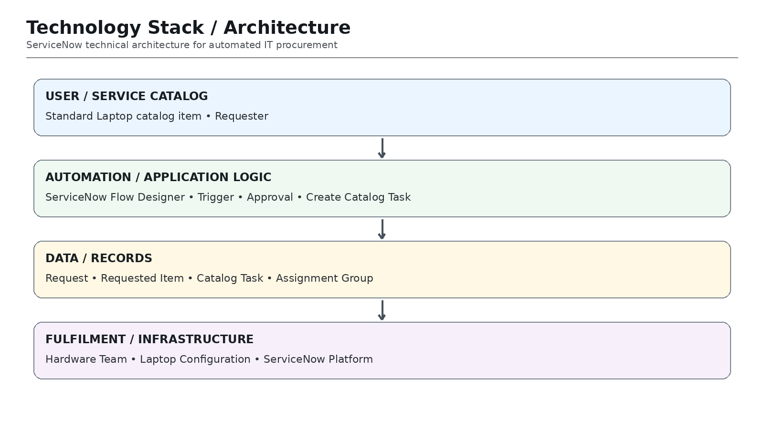
Table-1: Technology Components
S.No | Component | Description | Technology
1 | User Interface | How user interacts with application. | ServiceNow Service Catalog
2 | Application Logic | Logic for procurement workflow. | Flow Designer
3 | Approval | Request approval processing. | ServiceNow Approval
4 | Task Management | Creates and manages configuration task. | Catalog Task [sc_task]
5 | Database / Records | Request, Requested Item and Task data. | ServiceNow Tables
6 | Assignment | Routes work to the responsible team. | Hardware Assignment Group
7 | Infrastructure | Application hosting and execution. | ServiceNow Platform
Table-2: Application Characteristics
S.No | Characteristics | Description | Technology
1 | Platform Framework | ServiceNow platform and Flow Designer. | ServiceNow
2 | Security Implementation | Role-based access and controlled records. | ServiceNow ACL / Roles
3 | Scalable Architecture | Workflow can handle increasing request volumes. | ServiceNow Platform
4 | Availability | Cloud-hosted platform for workflow execution. | ServiceNow
5 | Performance | Event-driven automation reduces manual hand-offs. | Flow Designer
End-to-End Workflow:
Standard Laptop Catalog Item → User Places Order → Request Created → Request Approved → Requested Item Generated → Flow Triggered → Catalog Task Created → Hardware Team → Laptop Configuration

